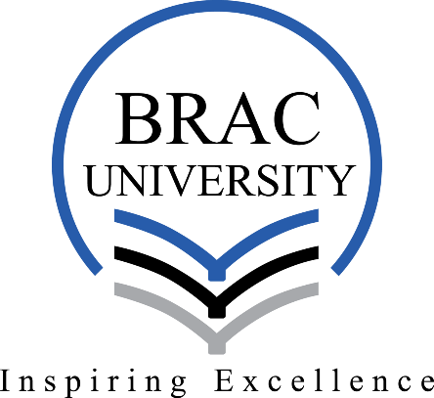

SDG Analysis: The Bihari Community of Bangladesh

CST309: Global Citizenship
Summer 2026

Name: Tahsin Raihan Robbani
Id: 22201344
Section: 1

Submitted Date: 15-08-2026
Submitted to
Sharmistha Ghosh
Assistant Professor
School of General Education
BRAC University

SDG Analysis: The Bihari Community of Bangladesh

The Bihari community's history of contested citizenship can be mapped onto two Sustainable Development Goals: SDG 16 (Peace, Justice and Strong Institutions) and SDG 10 (Reduced Inequalities). SDG 16, specifically target 16.9, calls for legal identity for all, including birth registration (United Nations, 2015). It can be applied directly here because the Biharis' central injury was decades of formal statelessness. Following the 1972 Citizenship Order, nearly 900,000 Urdu speakers were denied Bangladeshi citizenship while also being refused international refugee status because they had never crossed a border, leaving them in a legal void that Agamben (2000) termed a "permanent space of exception," "officially dead”. It only ended through sustained legal action and advocacy culminating in the 2003 and 2008 court rulings (Siddiqi, 2013, pp. 150, 164, 166). SDG 10, particularly target 10.2, calls for empowering and promoting the social, economic, and political inclusion of all irrespective of status (United Nations, 2015). It applies to the part of the Bihari experience that legal citizenship alone did not resolve, since even after 2008 many Biharis remained unable to secure passports, formal employment, or bank accounts, and continued living in overcrowded settlements such as Geneva Camp without secure land or economic opportunity (Siddiqi, 2013, p. 166). The goals reflect both sides of the Bihari story: SDG 16 focuses on the legal statelessness and the institutional fight needed to eradicate it; while SDG 10 addresses the social and economic exclusion that persisted even after legal statelessness was formally resolved.

References

Agamben, G. (2000). Means without end: Notes on politics (V. Binetti & C. Casarino, Trans.). University of Minnesota Press.
Siddiqi, D. M. (2013). Left behind by the nation: 'Stranded Pakistanis' in Bangladesh. Sites: New Series, 10(1), 150–183. https://doi.org/10.11157/sites-vol10iss2id253
United Nations. (2015). Transforming our world: The 2030 Agenda for Sustainable Development (A/RES/70/1). https://sdgs.un.org/2030agenda

